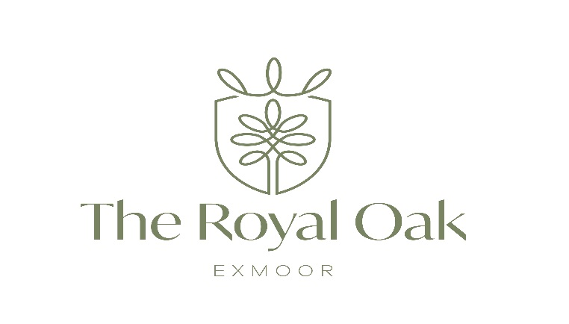

Sparkling wines (75cl bottles)
Prosecco Extra Dry 'Fili', Sacchetto.
Fine bubbles, fruity with a floral and fresh bouquet with hints of citrus on the finish 125ml-£6.00 £30.00
Champagne Bernard Remy, Brut 'Carte Blanche' Refreshing notes of lime and lemon combine with floral nuances, honey and brioche on the palate. Elegant and fresh. £55.00
Champagne Bernard Remy, Brut Rosé Lovely deep salmon colour, this elegant rose Champagne displays refreshing strawberry flavours with a deliciously clean and zesty finish. £60.00
Champagne Bollinger, This is a complex and elegant Champagne with a wonderful combination of velvety bubbles and flavours of pear, brioche, spice and fresh walnuts. £95.00

White Wines (75cl bottles)
Heraldique 'Cuvée Prestige Blanc', Pays d'Oc France. Aromas of tropical fruit and a creamy, spicy palate, full of flavour. Sauvignon Blanc, Colombard, Muscat blend. 125ml-£5.00 175ml-£6.50 250ml-£8.00 £20.00
Chardonnay Reserva, Viña Echeverría Chile. Creamy but unoaked, with fresh pear and tropical flavours and a soft finish.
125ml-£5.00 175ml-£6.50 250ml-£8.00 £23.00
Sauvignon Blanc Reserva, Viña Echeverría Chile Easy drinking with lively aromas of passion fruit and grapefruit with refreshing flavours of lemon. 125ml-£5.00 175ml-£6.50 250ml-£8.00 £23.00
Pinot Grigio, Rubicone, Novità Italy. Bursting with juicy pear flavours complemented by tangy notes of grapefruit zest
125ml-£5.00 175ml-£6.50 250ml-£8.00 £23.00
Piquepoul Terret 'l'Arête de Thau', Côtes de Thau France. Plentiful aromas of grapefruit and citrus fruit, with a vibrant palate and crisp finish £26.00
Chenin Blanc, Stellenbosch, Ernst Gouws. SA. Refreshing unoaked, displaying flavours of citrus and green apple with a vibrantly crisp finish. £27.00
Albariño 'Coral do Mar', Rías Baixas, Pazo do Mar. Spain. Fresh flavours of orange peel, peach and white flowers with a rich mouthfeel. £31.00
Gavi del Comune di Gavi 'Fossili', San Silvestro, Italy. Fresh and spicy with an appealing green apple and crystalline lemon flavour and mouth-watering, refreshing finish. £35.00
Rioja Blanco, 'Fermentado En Barrica', Nivarius Spain. A richly flavoured wine with beautifully balanced oak tones complemented by a saline minerality on the finish £37.00
Sauvignon Blanc 'Origin', Saint Clair Marlborough NZ. An herbaceous, crisp wine showing intense flavours of ripe gooseberry and pear over a creamy texture. £38.00
Domaine Grand Roche, Chablis 2022 A rich style of Chablis with typical saline and pineapple notes on nose and palate through to a dry, mouthwatering finish £45.00
Sancerre, J. de Villebois A textured and richly flavoured Sancerre with intense herbaceous, gooseberry and citrus aromas, beautifully balanced by a vibrant and refreshing crisp palate. £49.00
Meursault 1er Cru Genevrières, Philippe Bouzereau, Château de Cîteaux A top quality Meursault, this fine, elegant and complex wine is beautifully layered with a fresh minerality and a lovely long finish. £135.00

ROSÉ (75cl bottle)
Invitation Rosé', Costières de Nîmes, Château de Campuget, France Fruity and floral showing bright berried fruit and spice with a crisp and refreshing finish. Syrah/Grenache £26.00

REDS – 75cl bottle
Heraldique 'Cuvée Prestige Rouge', Pays d'Oc, France Medium bodied and flavoursome Southern French style full of juicy Ripe berried fruit with a touch of black pepper. Syrah/Grenache. 125ml-£5.00 175ml-£6.50 250ml-£8.00 £20.00
Montepulciano d'Abruzzo 'Feudi d'Albe', Bove Italy. Medium bodied red packed with red fruit flavours, easy and fresh-tasting. 125ml-£5.00 175ml-£6.50 250ml-£8.00 £24.00
Merlot, Valle Central, Tierra Antica Chile Red and black fruit aromas of juicy cherries and plums with a touch of chocolate, quaffable Merlot style. 125ml-£5.00 175ml-£6.50 250ml-£8.00 £24.00
Shiraz 'Foundstone', Vineyard. Australia - a fresh and juicy Shiraz with blackberry jam, eucalyptus and vanilla flavours. Benchmark Australian Shiraz. 125ml-£5.00 175ml-£6.50 250ml-£8.00 £24.00
Côtes du Rhône 'Est-Ouest', Domaine André Brunel France. Delicious and inviting Rhône showing warm, juicy and spicy black plum flavours with herbal echoes of the South of France. £27.00
Rioja Reserva, Bodegas Ondarre Spain. Leather, vanilla and spice of traditionally made Rioja enveloped in an elegant and textured palate. £35.00
Barbera d'Asti 'Le Orme', Michele Chiarlo Italy. A fresh and approachable Barbera with flavours of red cherry and cinnamon enhanced by wild herb tones. £37.00
Pinot Noir 'The Nest', Marlborough, Lake Chalice NZ. Light bodied and juicy Pinot Noir with aromatic notes of sweet ripe strawberries, dried herbs and red cherry, fresh and silky. £39.00
Malbec Premium, Cafayate, Piattelli Vineyards Argentina An elegant and fruit driven Malbec with a fruity bouquet of blackberry and violet with a touch of wild herbs and graphite. £39.00
Brouilly, Olivier Ravier. Beaujolais, France. A charming and textured Brouilly showing fresh aromas of red plum and typical graphite notes. £39.00
Chianti Classico 'San Jacopo' Italy. Smooth and elegant, a lovely and savoury expression of Chianti with red cherry and strawberry fruits ending with a silky finish. £43.00
Bordeaux Supérieur Château Lestrille Capmartin, Medium-bodied Bordeaux showing concentrated baked fruit aromas backed by delicate oaky notes complemented by a robust finish. £47.00
Châteauneuf-du-Pape, Domaine de la Solitude. A traditional yet modern style Châteauneuf with an elegant and velvety red berried quality complemented by savoury liquorice through to a fine and long finish. £65.00
Clos Brun Mazeyres, (2011) Pomerol A wine with a reputation of richness and a decadent reds, with notes of chocolate, dark cherry, plums and spice, soft tannins and elegance courtesy of the Merlot grape. £69.00

Chateau Sergant, (2014) Pomerol Pleasantly fruity aromas of dark berries mixed with cacao and mineral rich soil are a fitting prelude to the firm structure of this powerful wine. Ripe yet berry flavours persist amid the staunch minerals and medium grained leathery texture. £69.00
Chateau Malescasse (2014) Haut Medoc With a garnet colour, 2014 presents an intense nose of blackcurrant, blackberry and raspberry of great maturity. Molten notes of roasting and mocha give it great elegance and added complexity. £69.00
Chateau Cissac, Haut Medoc (2019) Aromas of dark fruit, cassis, plums and blackcurrants combine with hints of spice, vanilla, toast and cedar wood. £69.00
Château Cantenac Brown, (2015) 3ème Cru Classé, Margaux France Beautiful dusty tannins permeate this ripe wine. It has a smooth and rich texture, with bright blackberry flavours and a refreshing, vibrant close. £110.00
Gevrey Chambertin (2013) Louis Jadot The bouquet is inviting, with an array of red and black fruits like cherries and blackberries. This is accompanied by hints of earth, underbrush, and subtle toasted notes from the oak aging. £135.00

DESSERT WINES 37.5cl bottle
Elysium' Black Muscat, California USA An enticing aroma of water melon and roses combined with spicy strawberry fruit and a hint of caramelised orange, beautifully balanced. 125ml-£9.50 £28.00
Château Suduiraut, Castelnau de Suduiraut, Sauternes Elegantly rich and voluptuous with delicious flavours of honied oranges, peach and pineapple wrapped in barley sugar. 125ml-£10.50 £32.00

